UNIT-3
Advanced Data Access with Spring Data JPA: Spring Data JPA- Introduction to Spring Data JPA, Configuring JPA and connecting to databases, Creating repositories and CRUD operations. Advanced JPA- JPQL and native queries, Pagination and sorting, Relationships (One-to-One Relationships, One-to-Many Relationships, Many-to-Many Relationships).

Securing Spring: Enabling Spring Security, Configuring Spring Security (In-memory user store, JDBC-based user store, LDAP-backed user store, Customizing user, authentication), Securing web requests (Securing requests, Creating a custom login page, Logging out, Preventing cross-site request forgery), Knowing your user. Transaction Management- Understanding and managing transactions.
Textbook 1: Chapter 3:3.1 and 3.2
Textbook 1: Chapter 4:4.1 to 4.4

Advanced Data Access with Spring Data JPA

1. Introduction to Spring Data JPA
Spring Data JPA is a part of the Spring Framework that simplifies database interactions by reducing the need for boilerplate code. It provides a higher-level abstraction for working with JPA (Java Persistence API), allowing developers to focus on business logic rather than database interactions.
Key Features:
- Reduces boilerplate code
- Provides default implementations for CRUD operations
- Supports pagination and sorting
- Facilitates relationship mapping and querying
- Supports both JPQL and native SQL queries

What is Boilerplate Code?
Boilerplate code refers to repetitive, standard, or template-like code that is required in many places without significant modifications. It is often necessary for setting up basic functionality but does not contribute to business logic directly.

CRUD Operations?
CRUD stands for Create, Read, Update, and Delete—the four basic operations for interacting with a database.
- Create – Adding new records to the database.
- Read – Fetching or retrieving data.
- Update – Modifying existing data.
- Delete – Removing data from the database.

JPQL (Java Persistence Query Language)
JPQL is a query language similar to SQL but operates on JPA entity objects instead of database tables. It provides a more object-oriented approach to querying, ensuring database independence.

Key Features of JPQL
- Works with entity classes instead of table names.
- Uses entity field names instead of column names.
- Supports JOINs, filtering, sorting, and aggregation.
- Allows dynamic and named queries.

2. Configuring JPA and Connecting to Databases
To use Spring Data JPA, you need to configure JPA and connect it to a database.
Steps to Configure:
- Add Dependencies:
<dependency>
<groupId>org.springframework.boot</groupId>
<artifactId>spring-boot-starter-data-jpa</artifactId>
</dependency>
<dependency>
<groupId>com.h2database</groupId>
<artifactId>h2</artifactId>
<scope>runtime</scope>
</dependency>

What are Dependencies?
In software development, dependencies are external libraries or modules that a project requires to function properly. They provide additional functionality without requiring developers to write everything from scratch.

In a Spring Boot project, dependencies are managed using Maven (via pom.xml) or Gradle. These dependencies include essential components such as Spring Data JPA, databases (H2, MySQL, PostgreSQL, etc.), and other integrations.
Example of Dependencies in pom.xml:

2.Configure application.properties:
spring.datasource.url=jdbc:h2:mem:testdb
spring.datasource.driver-class-name=org.h2.Driver
spring.datasource.username=sa
spring.datasource.password=
spring.jpa.database-platform=org.hibernate.dialect.H2Dialect
spring.h2.console.enabled=true

3. Define Entity Class:
@Entity
public class Student {
@Id
@GeneratedValue(strategy = GenerationType.IDENTITY)
private Long id;
private String name;
private String email;
// Getters and Setters
}

4.Enable JPA Repositories:
@SpringBootApplication
@EnableJpaRepositories
public class Application {
public static void main(String[] args) {
SpringApplication.run(Application.class, args);
}
}

3. Creating Repositories and CRUD Operations
Spring Data JPA provides repository interfaces to handle common database operations.

Repository Interface Example:

public interface StudentRepository extends JpaRepository<Student, Long> {
}

CRUD Operations:
@Service
public class StudentService {
@Autowired
private StudentRepository repository;

public Student saveStudent(Student student) {
return repository.save(student);
}

public List<Student> getAllStudents() {
return repository.findAll();
}

public Optional<Student> getStudentById(Long id) {
return repository.findById(id);
}

public void deleteStudent(Long id) {
repository.deleteById(id);
}
}

4. Advanced JPA

4.1 JPQL and Native Queries
- JPQL (Java Persistence Query Language): Similar to SQL but operates on entity objects instead of tables.
- Native Queries: Directly execute SQL queries on the database.

JPQL Example:
@Query("SELECT s FROM Student s WHERE s.email = ?1")
Student findByEmail(String email);

Native Query Example:
@Query(value = "SELECT * FROM student WHERE email = ?1", nativeQuery = true)
Student findByEmailNative(String email);

2 Pagination and Sorting
Spring Data JPA provides built-in pagination and sorting using Pageable and Sort objects.
Example:
Page<Student> findAll(Pageable pageable);
List<Student> findAll(Sort sort);

Usage:
PageRequest pageable = PageRequest.of(0, 5, Sort.by("name").ascending());
Page<Student> students = studentRepository.findAll(pageable);

4.3 Relationships in JPA

JPA supports different types of relationships:

One-to-One Relationship: Each employee has one company ID card
@Entity
public class Passport {
@Id
@GeneratedValue(strategy = GenerationType.IDENTITY)
private Long id;
private String number;

@OneToOne(mappedBy = "passport")
private Student student;
}

One-to-Many Relationship: E-commerce Platform: A product can have multiple reviews.
@Entity
public class Course {
@Id
@GeneratedValue(strategy = GenerationType.IDENTITY)
private Long id;
private String title;

@OneToMany(mappedBy = "course")
private List<Student> students;
}

Many-to-Many Relationship:
@Entity
public class Student {
@ManyToMany
@JoinTable(name = "student_course",
joinColumns = @JoinColumn(name = "student_id"),
inverseJoinColumns = @JoinColumn(name = "course_id"))
private List<Course> courses;
}

University System: A student can enroll in multiple courses, and a course can have multiple students.
E-learning platforms (Coursera, Udemy, etc.): A student can enroll in many courses, and a course can have many students.

1. Securing Spring
Spring Security is a robust framework that provides authentication, authorization, and protection against common attacks. It is highly customizable and integrates deeply with the Spring ecosystem.

1.1 Enabling Spring Security
Theory:
By default, Spring Boot includes auto-configuration for security when the spring-boot-starter-security dependency is present. This enables basic security features such as form-based login, CSRF protection, and password encoding.
Key Concepts:
- Secure endpoints automatically
- Prevent unauthorized access
- Provide default login form
- Enforce user roles and permissions

How to Enable:
Simply include the dependency:
<dependency>
<groupId>org.springframework.boot</groupId>
<artifactId>spring-boot-starter-security</artifactId>
</dependency>

1.2 Configuring Spring Security
a) In-Memory User Store
Theory:
In-memory authentication is the simplest form of user store, ideal for development or testing. Users and their roles are defined directly in the application code.
Use Case: Small-scale apps, proof-of-concepts, or learning environments.

@Bean
public UserDetailsService userDetailsService() {
UserDetails user = User.withDefaultPasswordEncoder()
.username("user")
.password("pass")
.roles("USER")
.build();
return new InMemoryUserDetailsManager(user);
}

b) JDBC-based User Store
Theory:
For production systems, user information is often stored in relational databases. Spring Security can be configured to fetch user details from the database using JDBC.
Advantages:
- Centralized user management
- Persistent user store
- Integration with existing DB schema
Spring expects two tables: users and authorities. Custom queries can be used if your schema is different.

@Bean
public UserDetailsService jdbcUserDetailsService(DataSource dataSource) {
return new JdbcUserDetailsManager(dataSource);
}

c) LDAP-backed User Store
Theory:
LDAP (Lightweight Directory Access Protocol) is commonly used in enterprise environments for centralized user authentication and management.
Benefits:
- Centralized user control
- Scalability for large orgs
- Integration with corporate Active Directory
Spring Boot supports LDAP configuration through simple properties, enabling seamless connection to LDAP servers.

d) Customizing User Authentication
Theory:
For more flexibility, Spring allows custom authentication logic. You can define your own user store, credentials check, or authorization rules.
Use a custom UserDetailsService:

@Service
public class CustomUserDetailsService implements UserDetailsService {
@Override
public UserDetails loadUserByUsername(String username) {
// Load user from DB and return a UserDetails object
}
}

1.3 Securing Web Requests

a) Securing Requests
Theory:
Web application security involves controlling access to different parts of the application based on user roles. Spring Security allows URL-level access control.
Common Use Cases:
- Protect admin routes
- Limit access based on role
- Secure REST APIs
Example:
http.authorizeRequests()
.antMatchers("/admin/**").hasRole("ADMIN")
.antMatchers("/user/**").authenticated()
.anyRequest().permitAll();

b) Creating a Custom Login Page
Theory:
Spring Security provides a default login page, but for better user experience and branding, you can design your own.
You can use:
- HTML forms
- Thymeleaf integration
- Error messages for failed login

http.formLogin()
.loginPage("/custom-login")
.permitAll();

c) Logging Out
Theory:
Logging out invalidates the current session and clears security context.
http.logout()
.logoutUrl("/logout")
.logoutSuccessUrl("/login?logout");

Spring also provides:
- CSRF token clearing
- Session invalidation
- Cookie deletion

d) Preventing Cross-Site Request Forgery (CSRF)
Theory:
CSRF is a type of attack where unauthorized commands are transmitted from a user that the application trusts. Spring Security protects against this by requiring a special token in every modifying request (POST, PUT, DELETE).
Best Practice: Never disable CSRF in production applications unless you're building a stateless REST API.

In forms:
<input type="hidden" name="_csrf" value="${_csrf.token}"/>

1.4 Knowing Your User
Theory:
Understanding who the user is allows you to personalize the application and apply correct authorization rules.

Use Spring Security context:
Authentication auth = SecurityContextHolder.getContext().getAuthentication();
String username = auth.getName();

You can also inject the Principal object in controllers:

@GetMapping("/profile")
public String profile(Principal principal) {
return "Welcome " + principal.getName();
}

2. Transaction Management in Spring

2.1 What is a Transaction?
Theory:
A transaction is a set of operations that must all succeed or fail as a single unit. It ensures the ACID properties:
- Atomicity – All or nothing
- Consistency – Transitions from one valid state to another
- Isolation – Operations are isolated from others
- Durability – Changes are permanent after commit

2.2 Managing Transactions in Spring
Theory:
Spring offers both declarative and programmatic transaction management. The declarative model using annotations is preferred for simplicity and clarity.

2.3 Declarative Transaction Management
Use @Transactional to mark methods where all operations should be executed in a transaction.

@Transactional
public void updateAccountBalance() {
// debit and credit operations
}

Rollback Rules:
- By default, rolls back on RuntimeException
- Use rollbackFor for other exceptions

@Transactional(rollbackFor = IOException.class)

2.4 Programmatic Transaction Management
Theory:
Sometimes, you need fine-grained control, such as deciding to commit or roll back manually.

TransactionStatus status = transactionManager.getTransaction(def);
try {
// do operations
transactionManager.commit(status);
} catch (Exception e) {
transactionManager.rollback(status);
}

2.5 Transaction Propagation and Isolation
Propagation determines how transactions behave when called within other transactions:
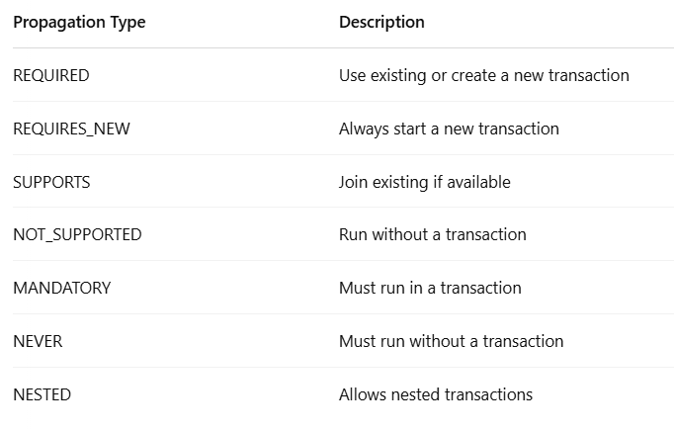

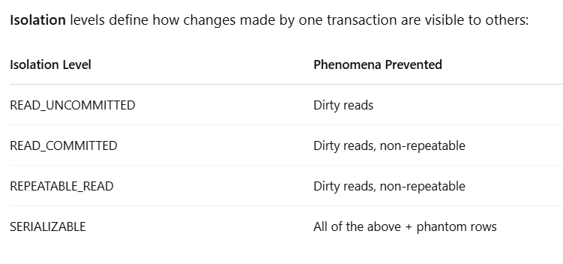

@Transactional(propagation = Propagation.REQUIRES_NEW,
isolation = Isolation.SERIALIZABLE)

Best Practices in Transaction Management
- Apply @Transactional at the service layer, not controllers.
- Keep transaction scopes small and efficient.
- Avoid nested transactions unless necessary.
- Use proper isolation levels for consistency and concurrency.

